ESC/POS control order

HT
[Name] | Horizontal tab
[Format] | ASCII | HT
 | Hex | 09
 | Decimal | 9
[Description] | Move the current position to the next tab position
[Note] | - If the next tab position werent set, this order should be ignored  - If the next horizontal tab position is beyond printing area, the current position should be set as [Printing width+1]  - Use ESC D to set the horizontal tab position.  - If current position is in[Printing width+1] when receiving this order, the printer runs the current buffer full actions and move printing position to the beginning of next line.  - The default tab position is to tab by each 8 standard ASCII characters(12x24)  - When the current buffer area is full, printer runs below actions: printer prints contents of current line and move the print position to the beginning of next line.
[Reference] | ESC D

LF
[Name | Print and line feed
[Format] | ASCII | LF
 | Hex | 0A
 | Decimal | 10
[Description] | Print the data in buffer and line feed
[Note] | - This order puts current position to the begins of a line
[Reference] | ESC 2, ESC 3

ESC SP n
[Name] | Set right-side character spacing
[Format] | ASCII | ESC | SP | n
 | Hex | 1B | 20 | n
 | Decimal | 27 | 32 | n
[Range] | 0n255
[Description] | Set the right-side character interspaces as N point
[Note] | - This setting only valid to character instead of Chinese.  - When character enlarges the interspaces enlarge correspondingly with same multiples.
[Default] | n=0
[Reference] | ESC 2, ESC 3

ESC ! n
[Name] | Select print mode(s)
[Format] | ASCII | ESC | ! | n
 | Hex | 1B | 21 | n
 | Decimal | 27 | 33 | n
[Range] | 0n255
[Description] | Set the character print mode by the N value  1/0 HEX Decimal Function  0,1,2 undefined  3 0 00 0 cancel the bold mode  1 08 8 select the bold mode  4 0 00 0 cancel the multi-high mode  1 10 16 select the multi-high mode  5 0 00 0 cancel the multi-wide mode  1 20 32 select the multi-wide mode  6 undefined  7 0 00 0 cancel the underline mode  1 80 128 select the underline mode
[Note] | - When selecting the multi-high and multi-wide mode in the same time, the characters double in either horizontal and vertical way.  - Except the spaces set by HT and characters printed by rotating, any other characters could be underlined.  - ESC- defines the underline but not the characters.  - When some characters within one line are multi-high or more, all characters align to bottom.  - ESC E could also select or cancel the bold mode. The final executed order is valid.  - ESC could also select or cancel underline mode. The final executed order is valid  - GS ! could also set the character size. Final executed order is valid.
[Default] | n=0
[Reference] | ESC -, ESC E, GS !

ESC $ nL nH
[Name] | Set absolute print position
[Format] | ASCII | ESC | $ | nL | nH
 | Hex | 1B | 24 | nL | nH
 | Decimal | 27 | 36 | nL | nH
[Range] | 0nL2550nH2
[Description] | Set the currently position to (nL+nHx256) dot from the beginning of a line.
[Note] | - If the preset position is out of print area, this order will be ignored.  - Both horizontal and vertical moving unit is set by GS P  - Use the horizontal moving unit under standard mode  - Under Page mode, we should select horizontal or vertical moving unit according to direction and beginning point of the print area. The selection as below: 1. When the beginning point is set at left upper corner or right bottom corner by ESC T, select the horizontal. 2. When the beginning point is set at left bottom corner or right upper corner by ESC T, then select vertical.
[Reference] | ESC \, GS \

ESC * m nL nH d1...dk
[Name] | Select bit-image mode
[Format] | ASCII | ESC | * | m | nL | nH | d1...dk
 | Hex | 1B | 2A | m | nL | nH | d1...dk
 | Decimal | 27 | 42 | m | nL | nH | d1...dk
[Range] | m = 0, 1, 32, 330 nL 2550 nH 30 d 255
[Description] | Select one of the bit-image modes designated by M. The bits are determined by nL and nH  m Mode Vertical Horizontal  Dot Resolution Resolution Data k  0 8 Dot single density 8 67DPI 100DPI nL+nH256  1 8 Dot double density 8 67DPI 200DPI nL+nH256  32 24 Dot single density 24 200DPI 100DPI (nL+nH256)3  33 24 Dot double density 24 200DPI 200DPI (nL+nH256)3
[Note] | - If the value of M exceeds range, nL and data after it will be executed as common data.  - The horizontal printer dots are determined by nL and nH. The total dots are nL+nHx256  - Bit-image which exceeds current area will be cut off.  - D is data of bit-image. When all the unit of data be 1 then it prints this dot, and no printers when be 0.  - After sending bit-image data, the printer returns to common data mode.  - ()This order wont be affected by other printing mode(bold, double printing, underline, zoom in) except the revert mode.  - The relation between data and dots going to be print is as below:  When selecting 8 dot density  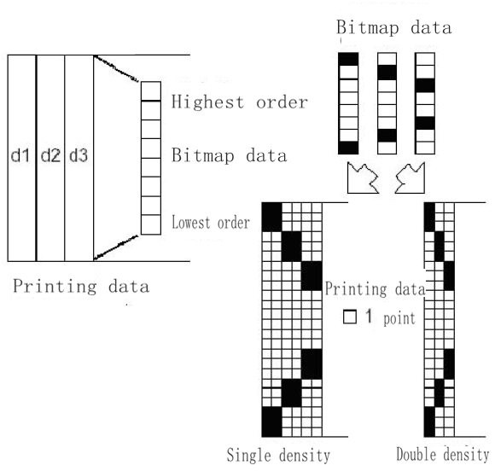  When selecting 14 dot density  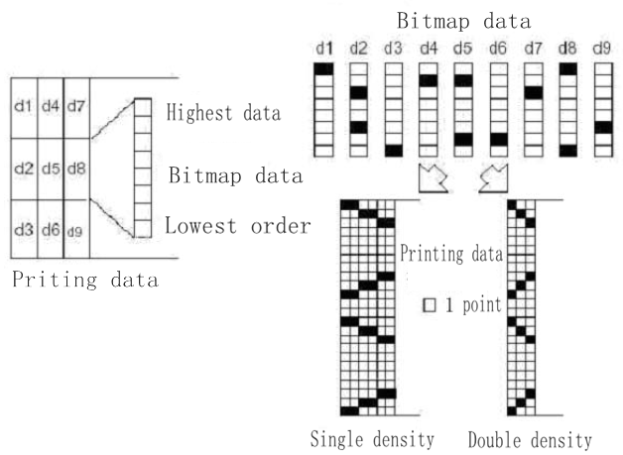

ESC n /
[Name] | Select/cancel user-defined character set
[Format] | ASCII | ESC | - | n
 | Hex | 1B | 2D | n
 | Decimal | 27 | 45 | n
[Range] | 0n248n50
[Description] | Select or cancel underline mode according to value of n  n Function  0,48 Cancel underline mode  1,49 Select underline mode(1 dot width)  2,50 Select underline mode(2 dot width)
[Note] | - The underline could be put under all characters(including right GAP) but not included spaces set by HT  - Underline cant be functioned to characters under rotating mode and revert display  - When canceling the underline mode, following characters are without underlines and underline width unchanged. Default width is one dot.  - Changing the character size wont affect current underline width  - The cancellation of underline could be set by ESC ! as well. The final executed order is valid.
[Default] | n=0
[Reference] | ESC !

ESC 2
[Name] | Select default line spacing
[Format] | ASCII | ESC | 2
 | Hex | 1B | 32
 | Decimal | 27 | 50
[Description] | Select 30 dots height.
[Note]
[Reference] | ESC 3

ESC 3 n
[Name] | Set line spacing
[Format] | ASCII | ESC | 3 | n
 | Hex | 1B | 33 | n
 | Decimal | 27 | 51 | n
[Range] | 0n255
[Description] | Set the height of line to be n dot
[Note]
[Default Value] | The default value of height of line is 30 dots.
[Reference] | ESC 2

ESC @
[Name] | Initialize printer
[Format] | ASCII | ESC | @
 | Hex | 1B | 40
 | Decimal | 27 | 64
[Description] | Eliminating the data in print buffer area. It is the default mode when printing mode is set as power on.
[Note] | - Save contents in order buffer area.

ESC D n1...nk NUL
[Name] | Set horizontal tab positions
[Format] | ASCII | ESC | D | n1...nk | NUL
 | Hex | 1B | 44 | n1...nk | 00
 | Decimal | 27 | 68 | n1...nk | 0
[Range] | 1 n 2550 k 32
[Description] | Set horizontal tab position.  - Set a tab position at the No.n line from beginning of the line.  - Totally therere k pcs of tab position.
[Note] | - The horizontal tab position is calculated by below formula: character width x n. Character width includes right GAP. If character is multi-wide, then the tab position multiplies correspondingly.  - This order cancels the previous setting of tab position  - When n=8, current tab position is No.9.  - Max 32(k=32) tab positions could be set. Data exceeds 32 will be regarded as common data.  - NULTab position is aligned by ascending order, the finished mark is NUL.  - When [n]k is less or equivalent to previous [n]k-1 value, the tab position ends. Following data is treated as common data.  - ESD D NUL cancels all tab position setting.  - Changing the character width wont change the designated tab position.  - Character width under standard mode and page mode is independent.
[Default] | Default tab position is each 8 standard ASCII character(12x24) with one tab position.
[Reference] | HT

ESC E n
[Name] | Turn emphasized mode on/off
[Format] | ASCII | ESC | E | n
 | Hex | 1B | 45 | n
 | Decimal | 27 | 69 | n
[Range] | 0n255
[Description] | Select or cancel bold mode  When the lowest position of n is 0, the bold mode canceled.  When the lowest position of n is 1, the bold mode selected
[Note] | - N validates only at lowest position  - /ESC ! could also select/cancel bold mode. The final received order is valid.
[Default] | n = 0
[Reference] | ESC !

ESC G n
[Name] | Turn on/off double-strike mode
[Format] | ASCII | ESC | G | n
 | Hex | 1B | 47 | n
 | Decimal | 27 | 71 | n
[Range] | 0n255
[Description] | Turn on/off double-strike mode  nWhen the lowest position of n is 0, cancel the double strike mode  n1When the lowest position of n is 1, turn on the double strike mode
[Note] | - N validates only at lowest position  - This order has same effect as bold printing.
[Default] | n = 0
[Reference] | ESC E

ESC J n
[Name] | Print and feed paper
[Format] | ASCII | ESC | J | n
 | Hex | 1B | 4A | n
 | Decimal | 27 | 74 | n
[Range] | 0n255
[Description] | Print the data in buffer area and feed paper for n dots line.
[Note] | - When printing finished, puts the current print position at beginning of line.  - ESC 2 ESC 3 Feeding of paper wont be affected by ESC 2 or ESC 3 order set.  - The max paper feed is 1016mm(40). If distance exceeds it, the max value is taken.
[Reference] | GS P

ESC V n
[Name] | Select rotation mode
[Format] | ASCII | ESC | V | n
 | Hex | 1B | 56 | n
 | Decimal | 27 | 86 | n
[Range] | 0 n 348 n 51
[Description] | n Function  0,48 Cancel rotated printing mode, printing character by normal  1,49 Selecting character rotated clockwise for 90 degrees and printing  2,50 Selecting character rotated clockwise for 180 degrees and printing  3,51 Selecting character rotated clockwise for 270 degrees and printing
[Reference] | - This command takes affect to all character,including chinese  - While choose the underline mode ,the underline of the word which has been rotated will not be printed.  - When in rotation mode and rotate 180 degrees ,double high and double width will the same as normal mode,rotate clockwise for 90 degrees or 270 degrees, double high and double width will contrary to normal.
[Default] | n = 0
[Reference] | ESC !, ESC -

ESC \ nL nH
[Name] | Set relative print position
[Format] | ASCII | ESC | \ | nL | nH
 | Hex | 1B | 5C | nL | nH
 | Decimal | 27 | 92 | nL | nH
[Range] | 0 nL 2550 nH 255
[Description] | Set relative print position by horizontal or vertical moving unit.  - This order sets the print position to (nL+nHx256) dot from current position.
[Note] | - Settings exceed printable area are ignored.  - When print position moves right: nL+nHx256=N  - nL+nH256=65536NWhen print position moves left, nL+nH256=65536N  - The print beginning point moves from current position to N dot.
[Reference] | ESC $

ESC a n
[Name] | Select justification
[Format] | ASCII | ESC | a | n
 | Hex | 1B | 61 | n
 | Decimal | 27 | 97 | n
[Range] | 0 n 248 n 50
[Description] | Keep all the printing data aligned by certain way.  Relation between alignment way and Value of N  n Alignment way  0,48 Left Alignment  1, 49 Middle  2, 50 right
[Note] | - This order works only for beginning of line under standard mode.  - This order changes only internal bit zone under page mode.  - This order adjusts space area according to HT,ESC $ or ESC \ order.
[Default value] | n = 0
[Example] | 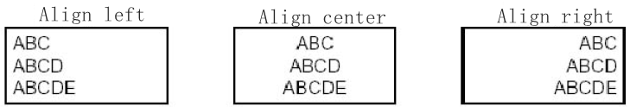

ESC d n
[Name] | Print and feed n lines
[Format] | ASCII | ESC | d | n
 | Hex | 1B | 64 | n
 | Decimal | 27 | 100 | n
[Range] | 0 n 255
[Description] | Print contents in buffer area and feed n lines(character line)
[Note] | - This command sets the start position of printer at the beginning of line.  - This command doesnt affect the line distance set by ESC2 or ESC3  - The max feeding distance is 1016mm. When value is larger than 1016mm, take the max instead
[Reference] | ESC 2, ESC 3

ESC { n /
[Name] | Turns on/off upside-down printing mode
[Name] | ASCII | ESC | { | n
 | Hex | 1B | 7B | n
 | Decimal | 27 | 123 | n
[Name] | 0 n 255
[Name] | selecting or cancel the invert printing mode:  Canceling the invert printing mode when the ns lowest order is 0.  When the lowest of n is 1,the printing mode is invert mode.
[Name] | - Value N only take affect on lowest order.  - This command take affect on the beginning of a line.  - In the invert printing mode, the printer will prints content after rotate all the line for 180 degrees.
[Reference] | n = 0
[Instance] | 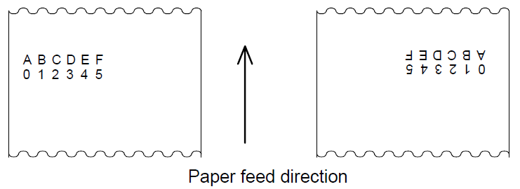

GS ! n
[Name] | Select character size
[Format] | ASCII | GS | ! | n
 | Hex | 1D | 21 | n
 | Decimal | 29 | 33 | n
[Range] | 0 n 2551 Vertical zoom in times 81 Horizontal zoom in times 8
[Description] | Use 0 to 3 to select character height, 4 to 7 to select character width. As below chart  Digit 0/1 Hex Decimal Function  0 Character height selectionsee chart2  1  2  3  4 Character width selectionsee chart1  5  6  7  chart1 Width selection chart2 Height selection  Hex Decimal Horizontal zoom in times Hex Decimal Vertical zoom in times  00 0 1 (Normal) 00 0 1 (Normal)  10 16 2 (2 times width) 01 1 2 (2 times height)  20 32 3 02 2 3  30 48 4 03 3 4  40 64 5 04 4 5  50 80 6 05 5 6  60 96 7 06 6 7  70 112 8 07 7 8
[Note] | - This command validates to all characters(ASCII and Chinese characters), besides  T the HRI Characters.  - If n exceeds regular Range, this command will be ignored.  - If same line of characters are with different magnifying times, all characters align to  Bottom.  - ESC ! commend could also select or cancel character width or height. The final  Received commend valid.
[Default value] | n = 0
[Reference] | ESC !

GS B n
[Name] | Turn white/black reverse printing mode
[Format] | ASCII | GS | B | n
 | Hex | 1D | 42 | n
 | Decimal | 29 | 66 | n
[Range] | 0 n 255
[Description] | /Select/Cancel white black reverse printing mode  - When the lowest of n is 0, cancel the reverse printing.  - When the lowest of N is 1, select the reverse printing.
[Note] | - N only validates to lowest position.  - This command is effective to all characters(except the HRI character)  - By selecting reverse printing, character distance set by ESC SP reverses too.  - HRI HT,ESC $,ESC \This command wont affect bmp, customized bmp, bar code HRI character and spaces set by HT,ESC $,ESC \  - This command wont affect spaces between lines.  - White black reverse printing mode has higher priority than underline mode. When selecting reverse mode, the underline mode palls on. It wont affect until the reverse mode is canceled.
[Default] | n = 0

GS H n
[Name] | Select printing position for HRI characters
[Format] | ASCII | GS | H | n
 | Hex | 1D | 48 | n
 | Decimal | 29 | 72 | n
[Range] | 0 n3 , 48 n51
[Description] | Select printing position for HRI character when printing bar codes.  N defines the HRI printing position  n printing position  0,48 No printing  1,49 Upon bar code  2,50 beneath bar code  3,51 print both up and beneath bar code  - HRI is character to Note bar code content
[Note]
[Default value] | n = 0
[Reference] | GS f, GS k

GS LnL nH
[Name] | Set left margin
[Format] | ASCII | GS | L | nL | nH
 | Hex | 1D | 4C | nL | nH
 | Decimal | 29 | 76 | nL | nH
[Range] | 0 nL255 , 0nH255
[Description] | - Set the left margin by nL and nH  - Set the left margin as [(nL+nH256)Horizontal moving unit)] Inch  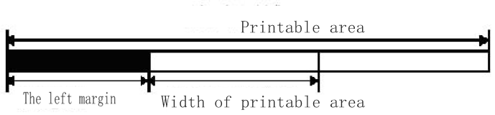Left margin, Width of print area
[Note] | - This command only effects at the beginning of line  - If setting exceeds max usable printing width, then take the max usable printing width
[Default] | nL = 0, nH = 0
[Reference] | GS W

GS W nL nH
[Name] | Set printing area width
[Format] | ASCII | GS | W | nL | nH
 | Hex | 1D | 57 | nL | nH
 | Decimal | 29 | 87 | nL | nH
[Range] | 0 nL255 , 0nH255
[Description] | - Set the printing area width by nL and nH  - Set the printing area width as (nL+nH256) dots  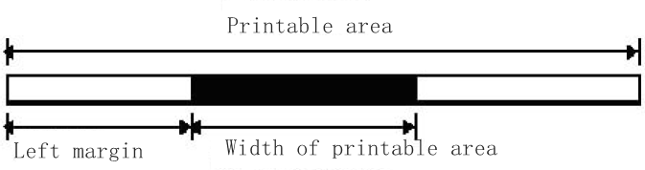
[Note] | - This command only effects at the beginning of line  - If (left margin+printing area width) exceeds printable area, then the printing area width is the printable width minus left margin.
[Default value] | nL = 76, nH = 2
[Reference] | GS L

GS h n
[Name] | Select bar code height
[Format] | ASCII | GS | h | n
 | Hex | 1D | 68 | n
 | Decimal | 29 | 104 | n
[Range] | 1 n 255
[Description] | Selecting the bar codes height
[Default] | n = 162
[Reference] | GS k

GS k m d1...dk NULGS k m n d1...dn
[Name] | Print bar code
[Format] | - ASCII | GS | k | m | d1...dk | NUL
 | Hex | 1D | 6B | m | d1...dk | 00
 | Decimal | 29 | 107 | m | d1...dk | 0
 | - ASCII | GS | k | m | n | d1...dn
 | Hex | 1D | 6B | m | n | d1...dn
 | Decimal | 29 | 107 | m | n | d1...dn
[Range] | - 0m6Value range of K and D is defined by bar code type  - 65m73Value range of K and D is defined by bar code type
[Description] | Select a bar code type to print bar codes. M is used for selecting bar code type, as below shows:  m Bar code type Character No. d Remark  0 UPC-A 11 k 12 48 d 57 12th is verification value  1 UPC-E 11 k 12 48 d 57  2 JAN13 (EAN13) 12 k 13 48 d 57 13th is verification value  3 JAN 8 (EAN8) 7 k 8 48 d 57 8th is verification value  4 CODE39 1 k 255 45 d 57, 65 d 90, d = 32,36, 37,43  5 ITF 1 k 255 (even Number) 48 d 57  6 CODABAR 1 k 255 48 d 57, 65 d 68, d = 36,43,45,46,47,58  65 UPC-A 11 n 12 48 d 57 12th is verification value  66 UPC-E 11 n 12 48 d 57  67 JAN13 (EAN13) 12 n 13 48 d 57 13th is verification value  68 JAN 8 (EAN8) 7 n 8 48 d 57 8th is verification value  69 CODE39 1 n 255 45 d 57, 65 d 90, d = 32,36, 37,43 d1 = dk = 42 Character>12too long to print  70 ITF 1 n 255 (Even Number) 48 d 57  71 CODABAR 1 n 255 48 d 57 65 d 68, d = 36,43,45,46,47 58  72 CODE93 1 n 255 0 d 127  73 CODE128 2 n 255 0 d 127
[Note] | - This command ends with NULL under such Format  - When selecting UPC-A or UPC-E code, the rest of characters will be processed as common character after printer receives 12 byte bar code data.  - When selecting JAN13(EAN13) type, the rest of characters will be processed as common character after printer receives 13 byte bar code data.  - When selecting JAN8(EAN8) type, the rest of characters will be processed as common character after printer receives 8 byte bar code data.  - The Number of ITF code data should be even number. If an odd number were entered, then the last digit will be ignored.
[Note] | - N is used for instructing numbers of bar code data. The printer processes the N byte data behind it as bar code data.  - RangeIf n exceeds regular Range, the printer doesnt process this command and processes subsequent data as common data.
[Note(Standard Mode)] | - The command void if barcode data d exceeds regular Range.  - If barcode horizontally exceeds printing area, Its void.  - No matter what line height is set by ESC2 or ESC 3, the feeding distance is equal to preset barcode height.  - This order effects only when printing buffer area is without data. It will be ignored if the buffer area has data.  - After printing barcode, set the printing position at the beginning of line.  - The print mode setting(such as bold, double print, underline, size of character, color reverse and character rotation) wont affect this order. But the reverse mode will effect the barcode printing.
[Note(Page mode)] | - This order only generates the barcode image to buffer area, but not printed. After processing barcode data, it moves the printing position to right side of barcode.  - If D exceeds the regular Range, this order will be ignored.  - If barcode width exceeds printing area, this order will be ignored.
[Reference] | GS H, GS f, GS h, GS w

GS v 0 m xL xH yL yH d1....dk
[Name] | Print raster bit image
[Format] | ASCII | GS | v | 0 | m | xL | xH | yL | yH | d1....dk
 | Hex | 1D | 76 | 30 | m | xL | xH | yL | yH | d1....dk
 | Decimal | 29 | 118 | 48 | m | xL | xH | yL | yH | d1....dk
[Range] | 0m348m510xL2550xH2550yL2550d255  k =(xL+xH256)(yL+yH256)(k0)
[Description] | Print Raster bit image, select the mode by m value  m mode Vertical resolution (DPI) Horizontal resolution (DPI)  0,48 standard mode 200 200  1,49 multi-width mode 200 100  2,50 Multi-height mode 100 200  3,51 Multi width and multi height mode 100 100  - xL,xH indicates byte qty on horizontal direction  - yL, yH indicates byte qty on vertical direction.
[Note] | - This order effects only when buffer area without data.  - Print modes such as zoom in, bold, double print, reverse print, under line, color reverse wont affect this order.  - Bmp which exceeds printing area wont be printed.  - ESC a(select align mode) effects to raster bit image.  - D represents bmp data. If corresponding position of each byte were 1 then print this dot, if it were 0 then this dot wont be printed.
[Instance] | xL+ (xH256) =64  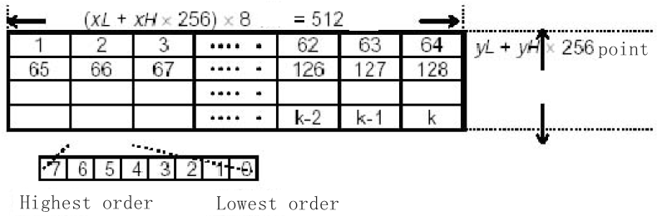highest position / lowest position

GS w n
[Name] | Set bar code width
[Format] | ASCII | GS | w | n
 | Hex | 1D | 77 | n
 | Decimal | 29 | 119 | n
[Range] | 2n6
[Description] | Set the horizontal width of barcode. Use n to designate the width  n Single standard mode width(mm) Dual standard mode width  Narrow standard mode(mm) Wide standard mode(mm)  2 0.25 0.25 0.625  3 0.375 0.375 1.0  4 0.5 0.5 1.25  5 0.625 0.625 1.625  6 0.75 0.75 1.875  - Single standard mode code is as followsUPC-A, UPC-E, JAN13(EAN13), JAN8(EAN8), CODE93,CODE128  - Wide standard mode code is as followCODE39,ITF,CODABAR
[Default] | n = 2
[Reference] | GS k

GS ( k pL pH cn fn [parameters]
[Name] | Set up and print symbol
[Description] | - Handle QR-Code data  - (pL + pH *256) determine the total account of (cn,fn and parameters)  - Cn assign QR-Code type ,fixed to 49.  - Fn assign command  - Parameters was assigned by different command  fn format No Function name  65 GS ( k pL pH cn fn n1 n2 165 QR-code:select mode (Invalid)  67 GS ( k pL pH cn fn n 167 QR-code: setting the qr-code size  69 GS ( k pL pH cn fn n 169 QR-code: select the error correction level  80 GS ( k pL pH cn fn m d1...dk 180 QR-code: .storage the qr-code data  81 GS ( k pL pH cn fn m 181 QR-code: print the qr-code which has been storage.  82 GS ( k pL pH cn fn m 182 QR-code: Getting the information of data which has been storated.
[Note] | The command which getting the size of saved data has been sended,there is no need to resending data before getting the return values.
[Reference]

<Function 167> GS ( k pL pH cn fn n(cn = 49, fn = 67)
[Name] | QR Code: Set the size of module
[Format] | ASCII | GS | ( | k | pL | pH | cn | fn | n
 | Hex | 1D | 28 | 6B | pL | pH | cn | fn | n
 | Decimal | 29 | 40 | 107 | pL | pH | cn | fn | n
[Range] | (pL+(pH+256))=3 (pL=3, pH=0)  cn = 49  fn = 67  1 n 16
[Description] | - Setting the QR-Code size to n point
[Default value] | n = 4
[Reference]

<Function 169> GS ( k pL pH cn fn n(cn = 49, fn = 69)
[Name] | QR Code: Select the error correction level
[Format] | ASCII | GS | ( | k | pL | pH | cn | fn | n
 | Hex | 1D | 28 | 6B | pL | pH | cn | fn | n
 | Decimal | 29 | 40 | 107 | pL | pH | cn | fn | n
[Range] | (pL+(pH+256))=3 (pL=3, pH=0)  cn = 49  fn = 69  48 n 51
[Description] | - Selecting QR-Code Error correctionlevel  N function Proportionofareatobecovered  48 Error correctionlevel L 7%  49 Error correctionlevel M 15%  50 Error correctionlevel Q 25%  51 Error correctionlevel H 30%
[Default] | n = 48
[Reference]

<Function 180> GS ( k pL pH cn fn m d1dk (cn = 49, fn = 80)
[Name] | QR Code: Store the data in the symbol storage area
[Format] | ASCII | GS | ( | k | pL | pH | cn | fn | m | d1dk
 | Hex | 1D | 28 | 6B | pL | pH | cn | fn | m | d1dk
 | Decimal | 29 | 40 | 107 | pL | pH | cn | fn | m | d1dk
[Range] | 4 (pL + pH 256) 7092 (0 pL 255, 0 pH 27)  cn = 49  fn = 80  m = 48  0 d 255  k = (pL + pH 256) 3
[Description] | - Storage QR-Code data(d1dk)
[Reference]

<Function 181> GS ( k pL pH cn fn m(cn = 49, fn = 81)
[Name] | QR Code: Print the symbol data in the symbol storage area
[Format] | ASCII | GS | ( | k | pL | pH | cn | fn | n
 | Hex | 1D | 28 | 6B | pL | pH | cn | fn | n
 | Decimal | 29 | 40 | 107 | pL | pH | cn | fn | n
[Format] | (pL+(pH+256))=3 (pL=3, pH=0)  cn = 49  fn = 81  m = 48
[Description] | - Decoding code
[Note] | While printing QR-Code, you must control blank area youself
[Reference]

Chinese character control order

FS ! n Set print mode for Chinese characters.
[Name] | Set print mode(s) for Chinese characters
[Format] | ASCII | FS | ! | n
 | Hex | 1C | 21 | n
 | Decimal | 28 | 33 | n
[Range] | 0n255
[Description] | 1/0 HEX Decimal  0,1 - - - .not define  2 0 00 0 .canceling quadruple-size width mode  1 04 4 .selecting quadruple-size width mode  3 0 00 0 .canceling quadruple-size height mode  1 08 8 selecting quadruple-size height mode  4-6 - - - not define  7 0 00 0 canceling underline mode  1 80 128 selecting underline mode
[Note] | - While the quadruple-size height and width has been set, the character will be zoom in two size  - The printer will adding underline to each character ,including left and right space. But not take affect on blank cause by HT command, not take affect on character which has been rotated 90 degrees.  - You can bold font by using FS W or GSthe last command take affect.  - You can turn the underline mode on/off by using FS -,The last command will take affect.
[Default value] | n=0
[Reference] | FS , FS W, GS !

FS &
[Name] | Select Chinese character mode
[Format] | ASCII | FS | &
 | Hex | 1C | 26
 | Decimal | 28 | 38
[Description] | Select Chinese character mode
[Note] | - While choosing the chinese character mode ,the printer will judge if the Chinese character is internal code. Handling the first character then judge the if the next character s internal code.  - The printer will automatic select the Chinese mode while the printer is power on.
[Reference] | FS .

FS - n
[Name] | Turn underline mode on/off for Chinese characters
[Format] | ASCII | FS | - | n
 | Hex | 1C | 2D | n
 | Decimal | 28 | 45 | n
[Range] | 0n248n50
[Description] | Selecting or Canceling the underline mode by the value of n  n Function  0,48 Canceling the Chinese characters underline  1,49 Selecting the Chinese characters underline(1 point in width)  2,50 Selecting the Chinese characters underline(2 point in width)
[Note] | The printer will add underline to each character ,including left and right space. But not added by the command which cause by HT command, not take affect to the rotated character by 90 degrees which with underline.  - The printer will not execute the underline print, but the line width of underline you set former.The default line width is 1 point.  - Even if you changing the size of character, the underline which you set will not be changed.  - You can canceling the underline mode by using FS!, the last command take affect.
[Default value] | n=0
[Reference] | FS !

FS .
[Name] | Cancel Chinese character mode
[Format] | ASCII | FS | .
 | Hex | 1C | 2E
 | Decimal | 28 | 46
[Description] | Canceling Chinese character mode
[Note] | - While all the Chinese character has been canceled ,all those character will be regard as ASCII, the system will handle only one character each time.  - Power on and automatic selecting Chinese character mode.
[Reference] | FS&

FS C n
[Name] | Select Kanji character code system
[Format] | ASCII | FS | C | n
 | Hex | 1C | 43 | n
 | Decimal | 28 | 67 | n
[Range] | 0n248n50
[Description] | n Encoding system  0,48 GBK simple Chinese  1,49 BIG5 traditional Chinese  2,50 KSC5601 korean
[Default value] | n=0
[Reference]

FS S n1 n2
[Name] | Set left- and right-side Chinese character spacing
[Format] | ASCII | FS | S | n1 | n2
 | Hex | 1C | 53 | n1 | n2
 | Decimal | 28 | 83 | n1 | n2
[Range] | 0 n1 255 , 0 n2255
[Description] | Setting the right&left space to n1 and n2
[Note]
[Default value] | n1 = 0n2 = 0

FS W n
[Name] | Turn quadruple-size mode on/off for Chinese characters
[Format] | ASCII | FS | W | n
 | Hex | 1C | 57 | n
 | Decimal | 28 | 87 | n
[Range] | 0n255
[Description] | Selecting or canceling Chinese quadruple-size mode on/off for Chinese characters.  - While the lowest of n is 0,turing the quadruple-size mode off.  - While the lowest of n is 1,turning the quadruple-size height mode on.
[Note] | - Only the lowest of n take affect.  - While the quadruple-size mode for Chinese characters is on, the later Chinese characters printed is the same .  - While the quadruple-size mode for Chinese characters is off, the later Chinese characters printed is normal.  - While the height of each character is different in one line, all the character of the line will aligned at the base line.  - You can also selecting or canceling Chinese quadruple-size height and width , the last command will take affect.
[Default value] | n=0
[Reference] | FS !GS !

[Name] | Cut paper
[Format] | byte［4］ ：0x1d 0x56 0x42 0x00  byte［4］ ：0x1d 0x56 0x41 0x00

[Name] | Open Money boxr
[Format] | byte［5］：0x10 0x14 0x00 0x00 0x00

